Tung Wah Group of Hospitals
Good People, Good Deeds: English Writing Competition 2022-23
Student Information Form
*Junior/Middle/Senior Level

Junior Level (Primary 4 – Primary 6)
Middle Level (Secondary 1 – Secondary 3)
Senior Level (Secondary 4 – Secondary 6)

Submission of Forms:
Each school should fill in one Student Information Form for all participants of each level on or before 28th April 2023 and upload it (in both WORD and PDF format) to Official Entry Form by Google Form at https://forms.gle/1mjrPiv8LYVyp5Ue8.
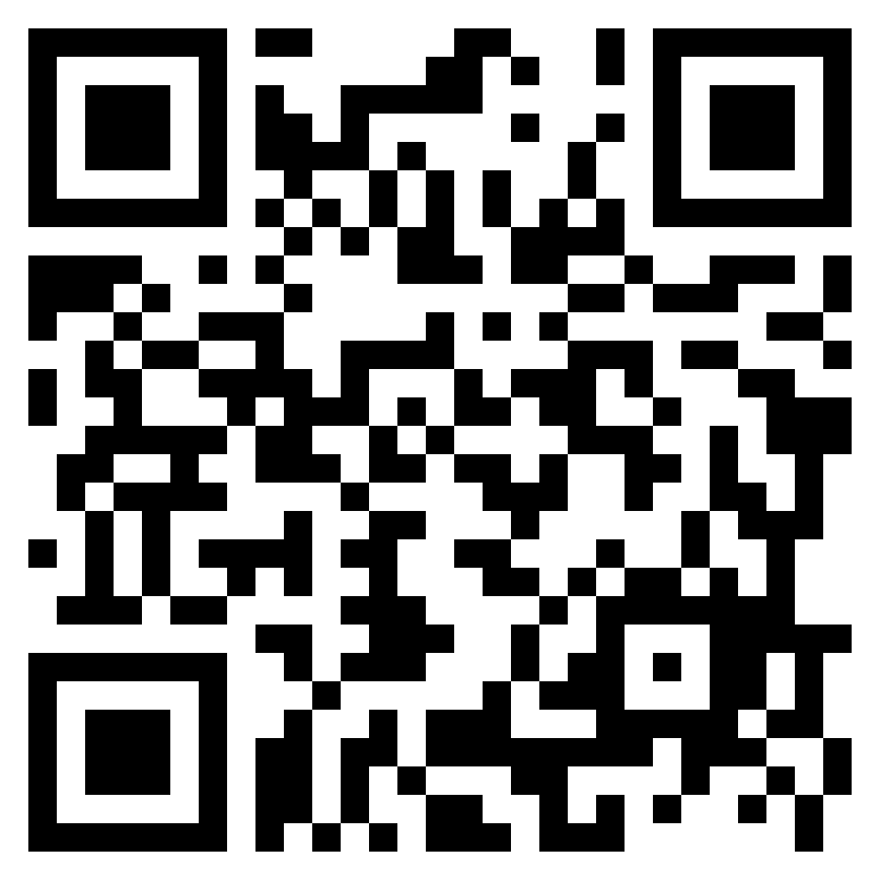

Should you have any enquiries, you are advised to contact Ms Keith TONG at 2859-7655 or twghsgpgd@gmail.com.

Please complete the form in BLOCK LETTERS

Student Information of Top 10 Entries

 | No. | Submission Title | Student Full Name | Student Form Level
Best Three | 1.
 | 2.
 | 3.
 | 4.
 | 5.
 | 6.
 | 7.
 | 8.
 | 9.
 | 10.

*Please delete as appropriate.
Signature of Principal /School Head:
Name:
Date:
School Stamp

